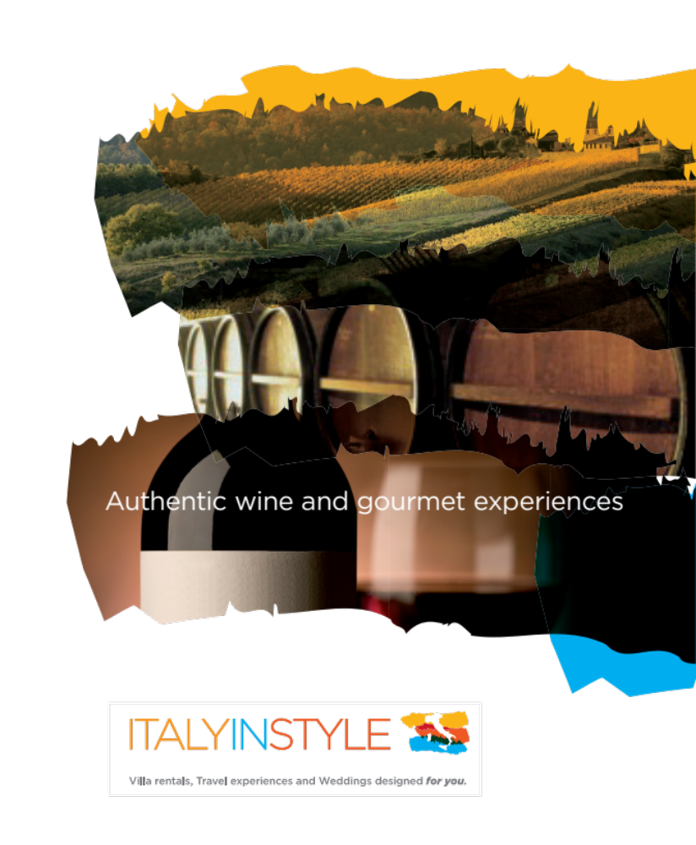 Authentic wine and gourmet experiences


Enjoy Sicily

Brief Area History: After some 25 centuries of foreign domination, Sicilians are heir to an impressive cultural legacy, from the refined architecture of Magna Graecia to the startling artistic fusion of Arab craftsmanship and Norman austerity. Complexity of culture is only matched by stunning natural beauty and diversity of landscapes; rolling hills and valleys, brooding Etna, kilometres of aquamarine coastline and a necklace of encircling islands.

Day 1: Welcome to Sicily

Check-in at Hotel Splendid La Torre, Mondello
http://www.latorrehotel.it/index.php/en/

Welcome dinner with Connie Costa (not included in the package).

Day 2: Palermo

Breakfast. Transfer to Palazzo Lampedusa.

Meet your Chef, Duchess Nicoletta at her historic palazzo, Palazzo Lampedusa. Visit to one of Palermo’s historic markets (Il Capo, La Vucciria or Borgo Vecchio). At the market, meet the Market's lively characters, see fish fly and, purchase the freshest selection of produce to prepare your meal. This cooking demonstration is held at the Duchess’ palazzo in the heart of Palermo. A late lunch will follow the class.
After lunch meet your driver and English speaking guide and depart for a tour of Palermo (entrance fees to the Cathedral, Cappella Palatina and Monreale included)

Founded by the Phoenicians in the eighth and seventh centuries B.C., it was conquered by the Arabs in 831, and a period of immense prosperity commenced. You'll be enchanted by Palermo's wide boulevards, traditional Sicilian Old Quarter, and baroque palaces. You'll see the city's main sights, including Quattro Canti di Citta' (the Four Corners of the City), Palermo's extravagant baroque square. The square is ringed by four buildings with baroque sculptures that depict the Four Seasons, Spanish kings, and the patron saints of Palermo's four old quarters. See the twelfth-century Cathedral of Palermo, which houses a pantheon of royal tombs.

Then drive to Monreale to see its famous Arab-Norman Cathedral and Cloister, the pinnacle of art for this period in Sicily.

Return to your hotel.

Day 3: Palermo

Surprise day....

Day 4: Palermo/Taormina

In the morning depart to Cefalù with your driver guide. This enchanting fishing village and summertime resort sits on a rocky outcrop in the centre of Sicily’s north coast.
Cefalù lies in a scenic locale between the massive peak and a long sweeping beach. Against this backdrop rise the lofty twin towers of the cathedral built by Roger II in 1130. This splendid cathedral is one of the finest examples of Arab-Norman architecture, and contains luminous mosaics.

Time at leisure.

Proceed to Taormina.

Taormina is Sicily’s most famous city. Dating from the fourth and third centuries B.C., it is perched dramatically high on a rocky promontory overlooking the Ionian Sea. It’s a charming medieval town with typical cobblestoned streets leading into spacious squares graced by lovely 15th-century palazzi. One of the town’s highlights is the extraordinary classical Greco-Roman theatre.

Check-in at Hotel Caparena by the sea in Taormina Bassa.
http://www.hotelcaparena.com/en/home.html/

Day 5 : Syracuse

In the morning departure to Syracuse. one of the most beautiful Sicilian towns.

You will visit the major archaeological sites, including the famous Greek Theater, “The Ear of Dionysius,” and take a walking tour of Ortigia Island to admire the architectural splendour of ancient streets, baroque palaces, and classic churches as the Duomo, built upon the old temple of Athena.
Lunch is in a local deli with tasting of artisanal cheeses, cold cuts and local wine.

Return to Taormina.

Day 6: Cooking class

In the morning transfer to Viagrande on Mount Etna.
Meet Eleonora Consoli in her La Cucina del Sole. Eleonora has written several cookbooks on Sicilian gastronomy and she is an official expert on Sicilian cooking in the world.

She will lead a hands-on cooking class, featuring several classic Sicilian dishes including appetizers, a pasta dish, a second course and dessert.
Lunch is served at Eleonora's home.

After lunch return to Taormina. Afternoon at leisure.

Day 7 - Arrivederci Sicilia!

Breakfast in hotel. Check-out.

Costa’s Luxury Diamante Tour (5-star accommodations)

Price per person, sharing a double room from $ 7,000

Custom-designed tours available

Costa’s Food & Wine Tour

Price per person, sharing a double room $ 3,900

Please note: prices will go up! Book now!

Itinerary subject to change.

The quote includes
- 3 BB in Palermo
- 3 BB in Taormina
- Accommodation in 4 star hotels (5-star for the Diamante Tour)
- English Speaking Guide and Entrance fees in Syracuse, Palermo and Monreale
- Lunch in Syracuse
- Cooking class and lunch at an historic Palace in Palermo
- Cooking class and lunch at La Cucina del Sole, Mt. Etna

The quote does not include
- International and domestic airfare
- Meals not included in the itinerary
- Beverages
- Travel insurance
- Personal expenses

